RAJASHEKAR CHITUMALLA

2503B05126

SET 1

Q1. (Data Structures – 5 Marks)
Using AI assistance, write a Python program to implement a Stack using a list.
Perform the following operations:
- Push 5 elements
- Pop 2 elements
- Display the remaining stack
Explain how AI helped generate or optimize your structure.
PROMPT :
Using AI assistance, write a Python program to implement a Stack using a list.
Perform the following operations:
- Push 5 elements
- Pop 2 elements
Display the remaining stack
Explain how AI helped generate or optimize your structure
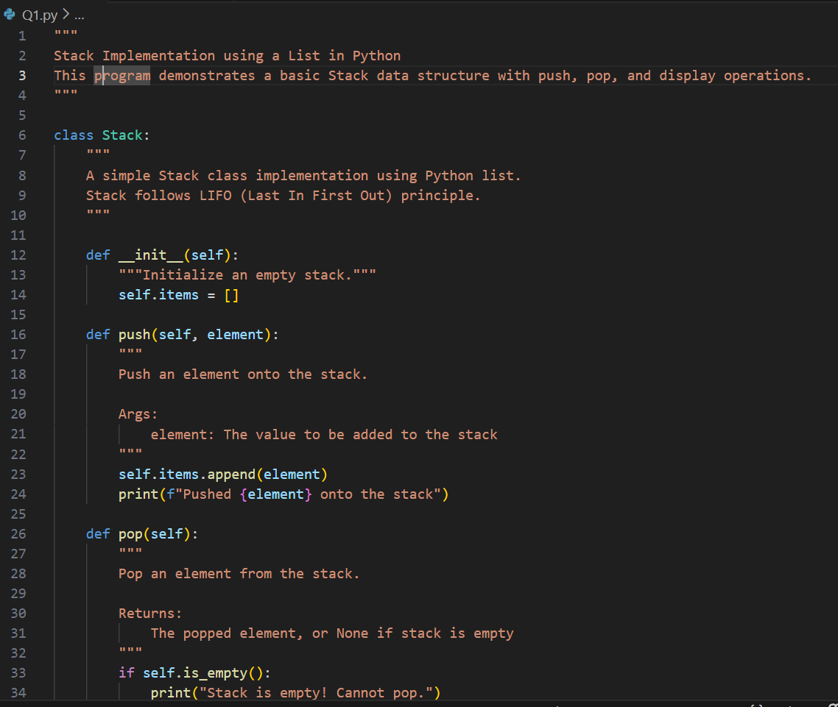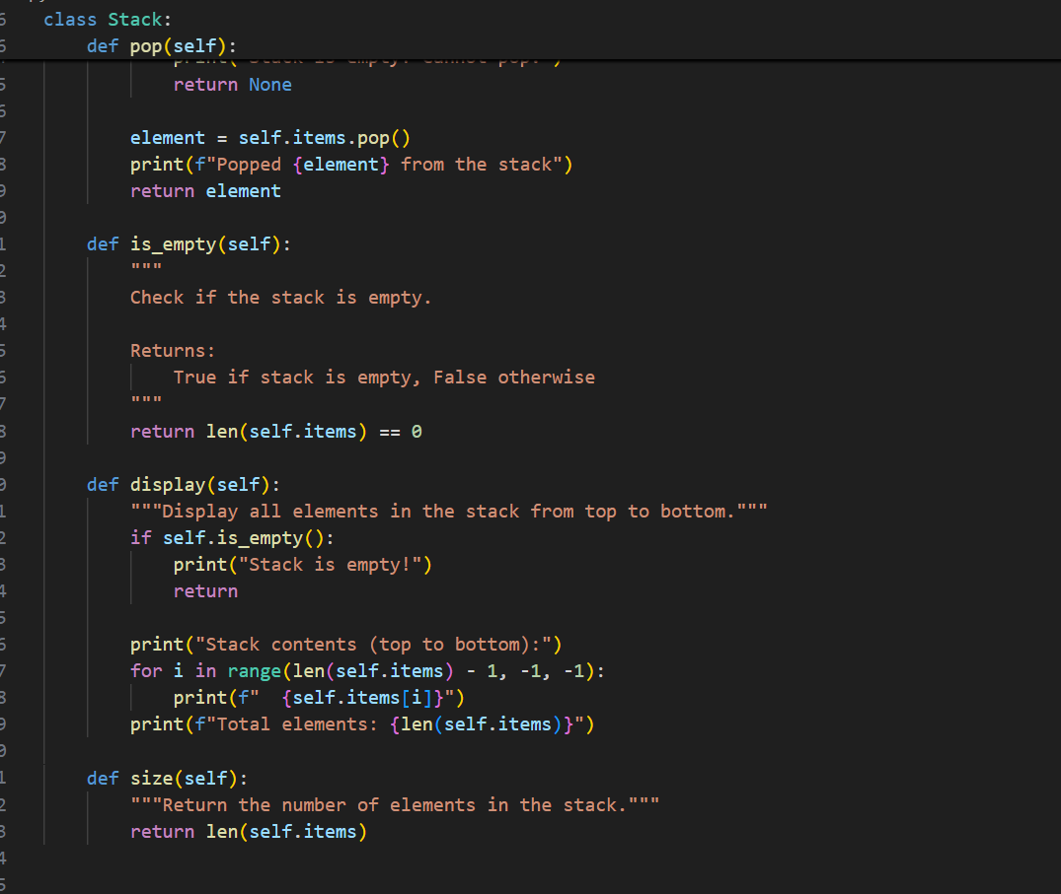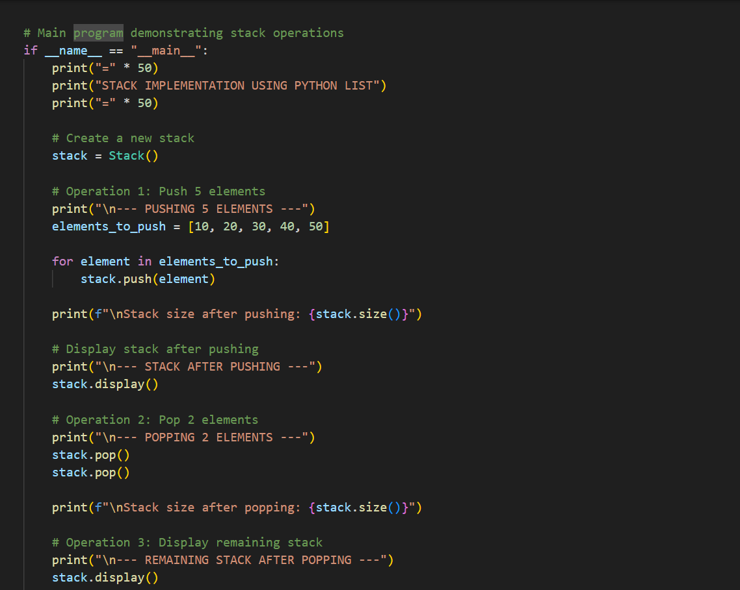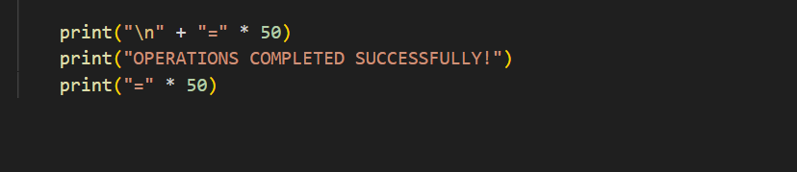
OUTPUT :
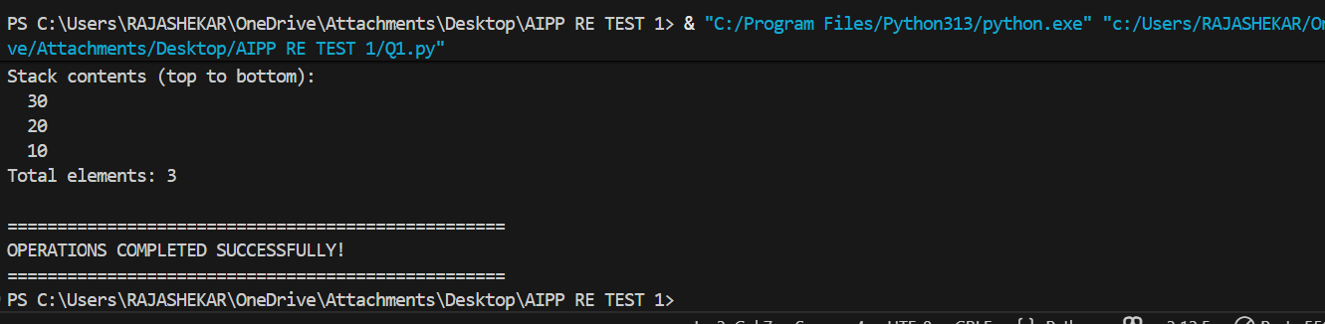

Q2. (Web Frontend – 5 Marks)
With AI tools, develop an interactive To-Do List App using HTML, CSS, and JavaScript.
Include features:
- Add task
- Delete task
- Mark as completed
PROMPT :
With AI tools, develop an interactive To-Do List App using HTML, CSS, and JavaScript.
Include features:
- Add task
- Delete task
- Mark as completed

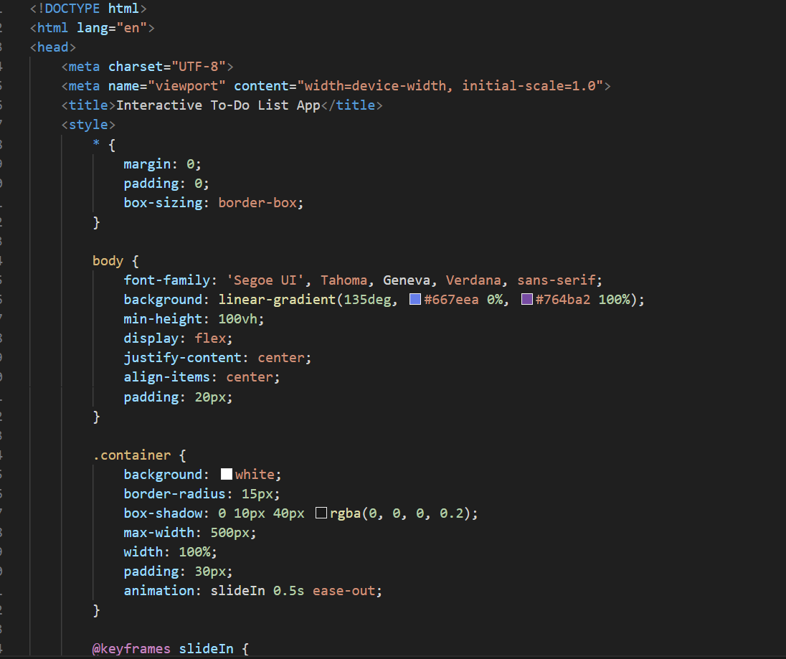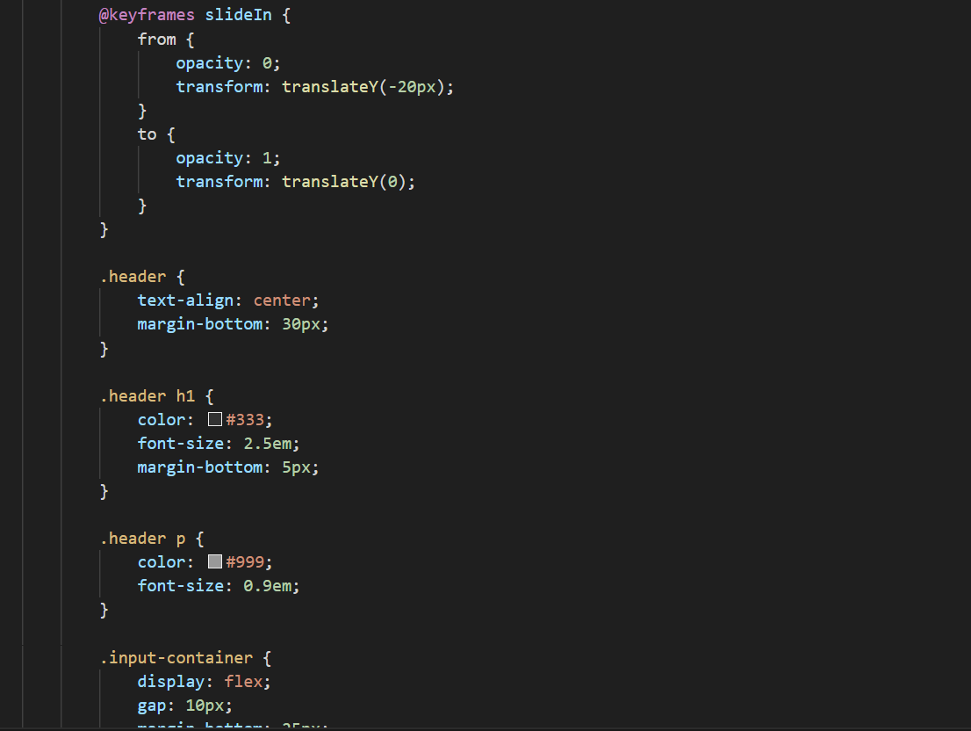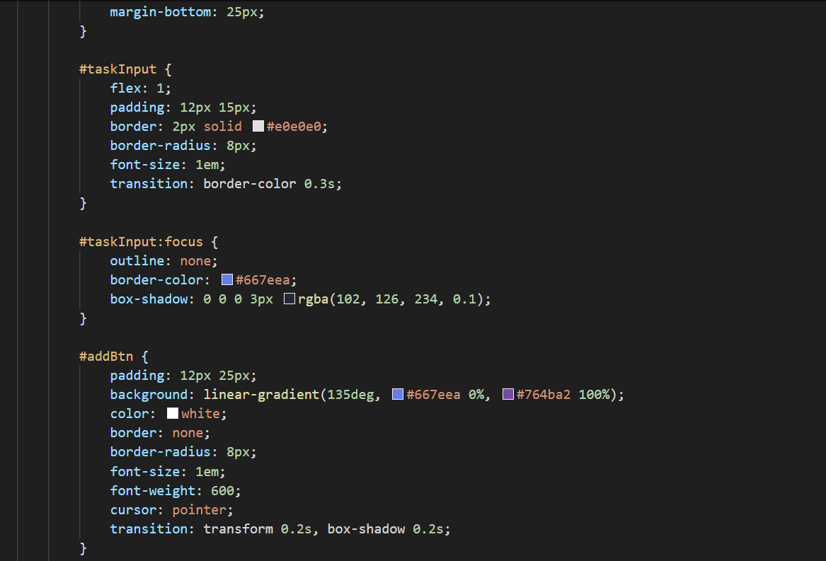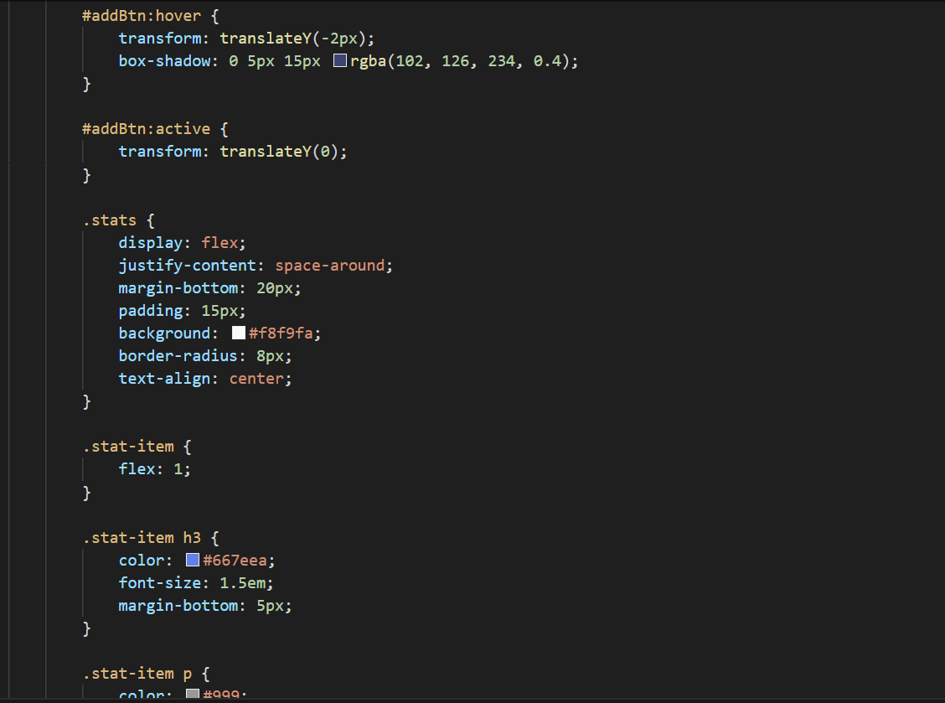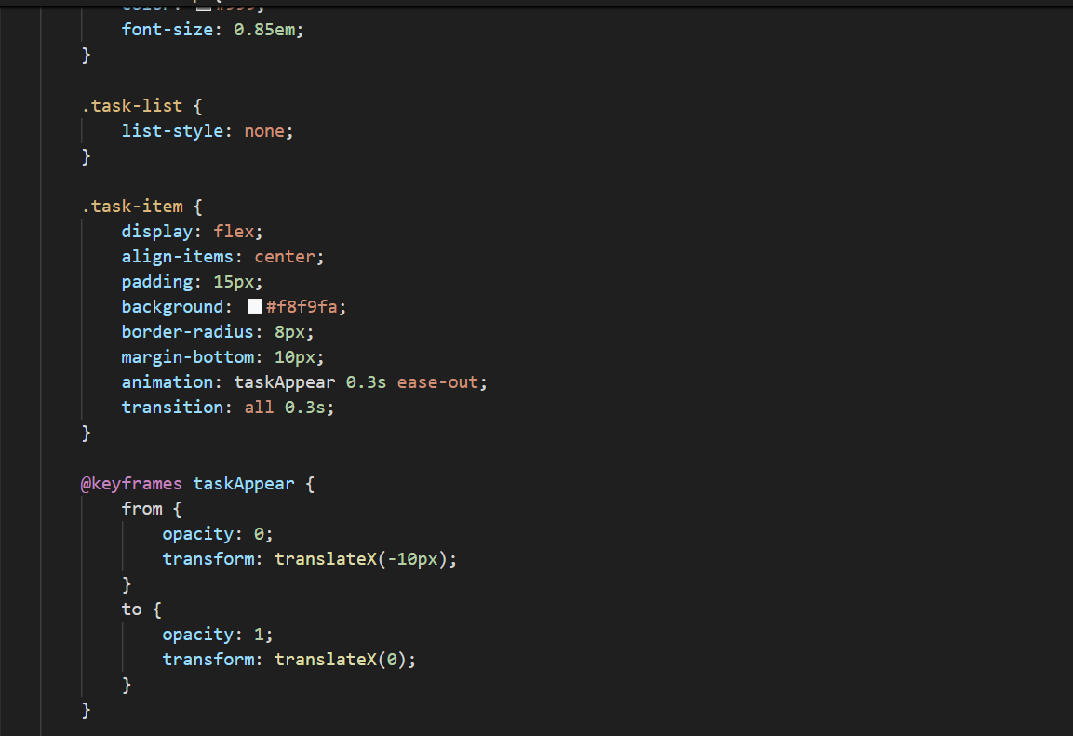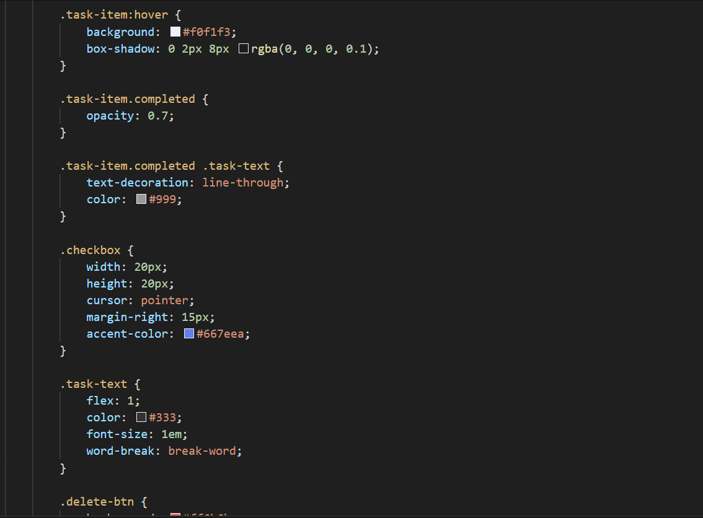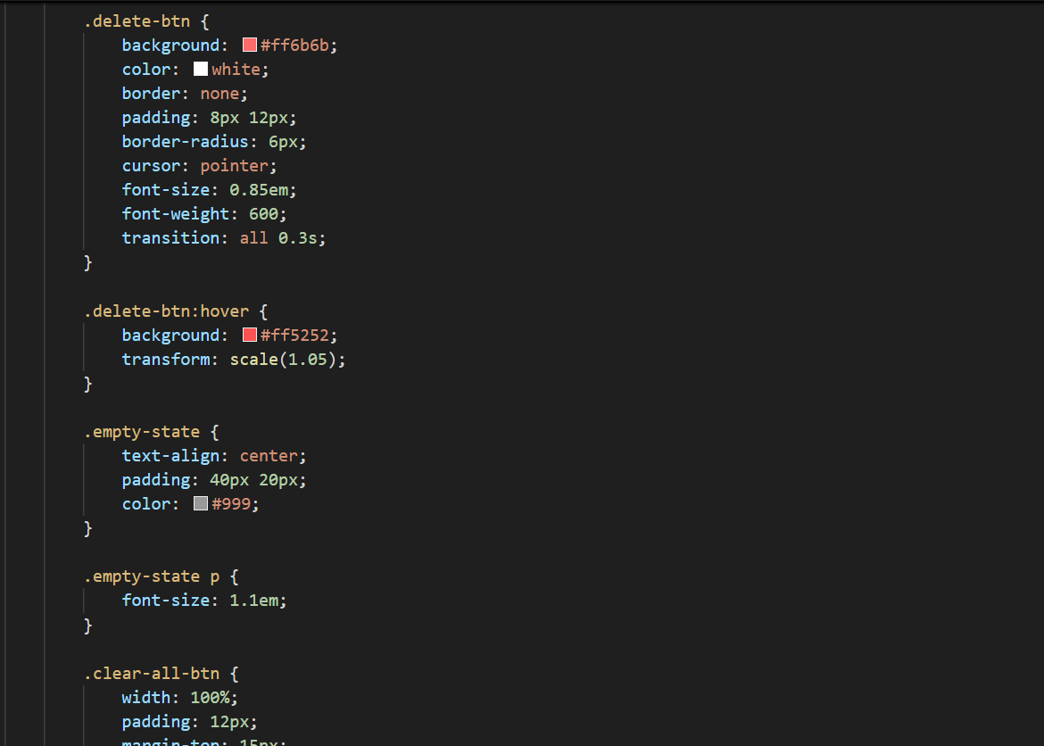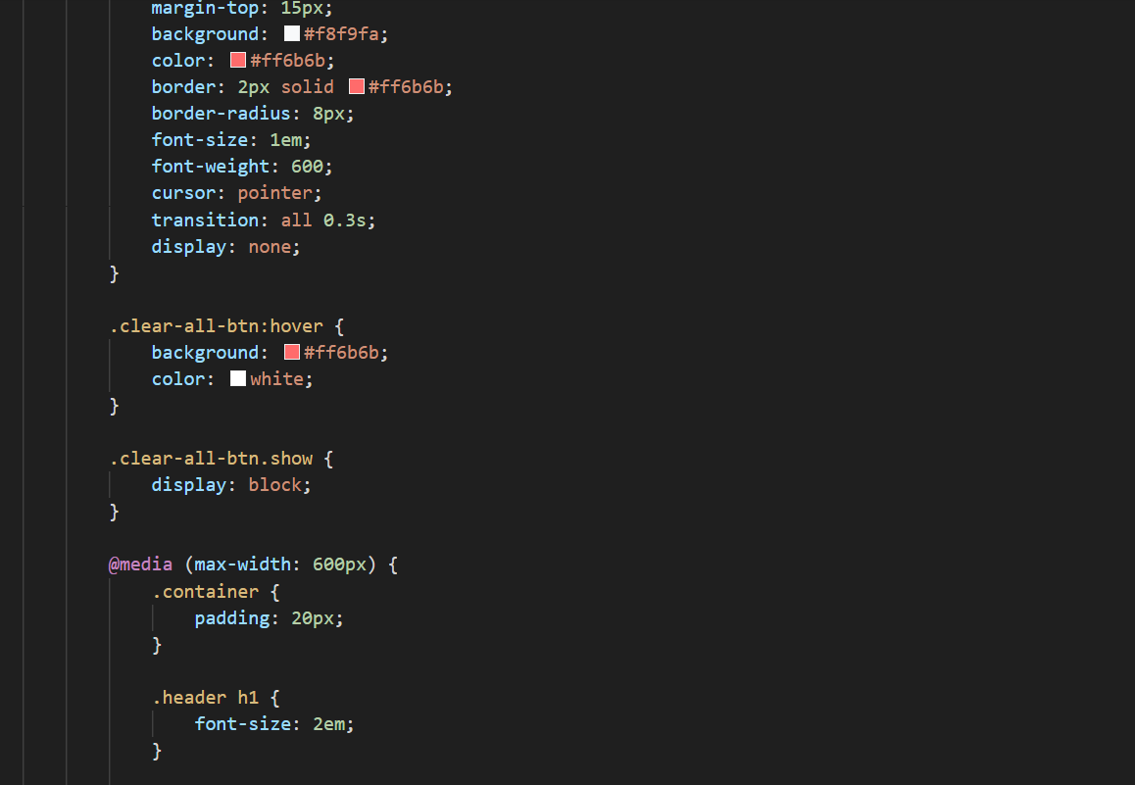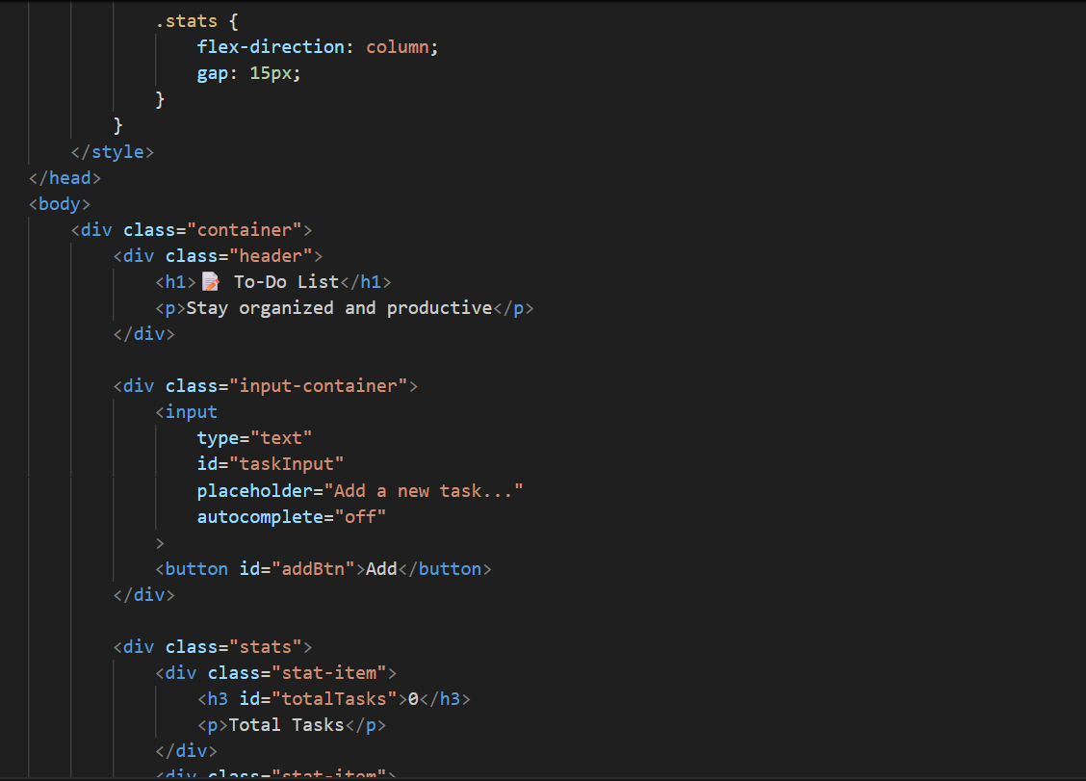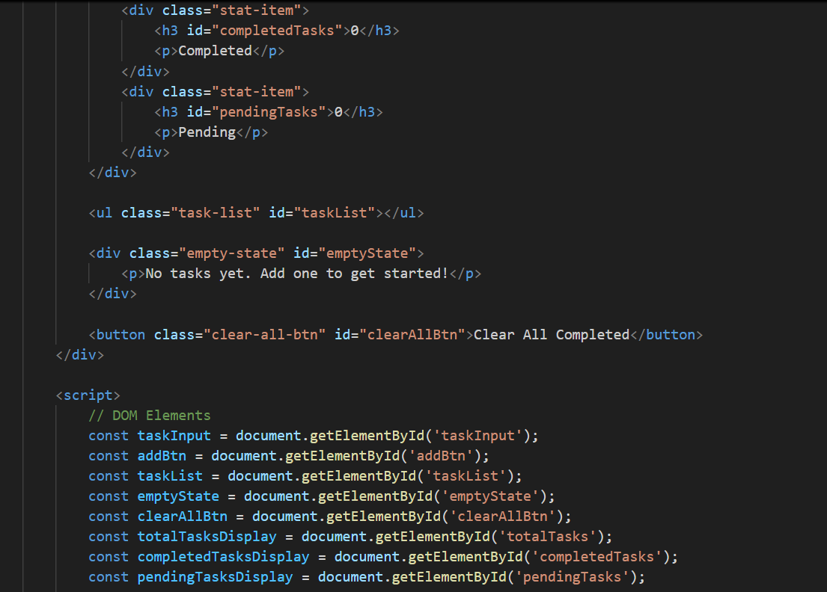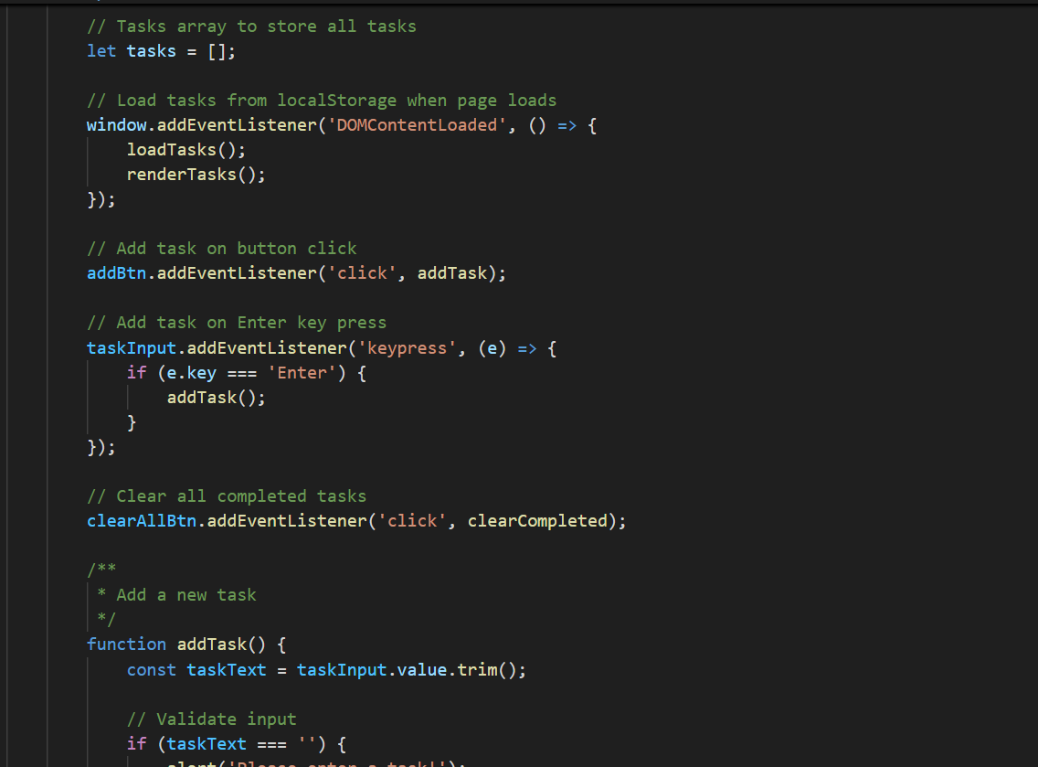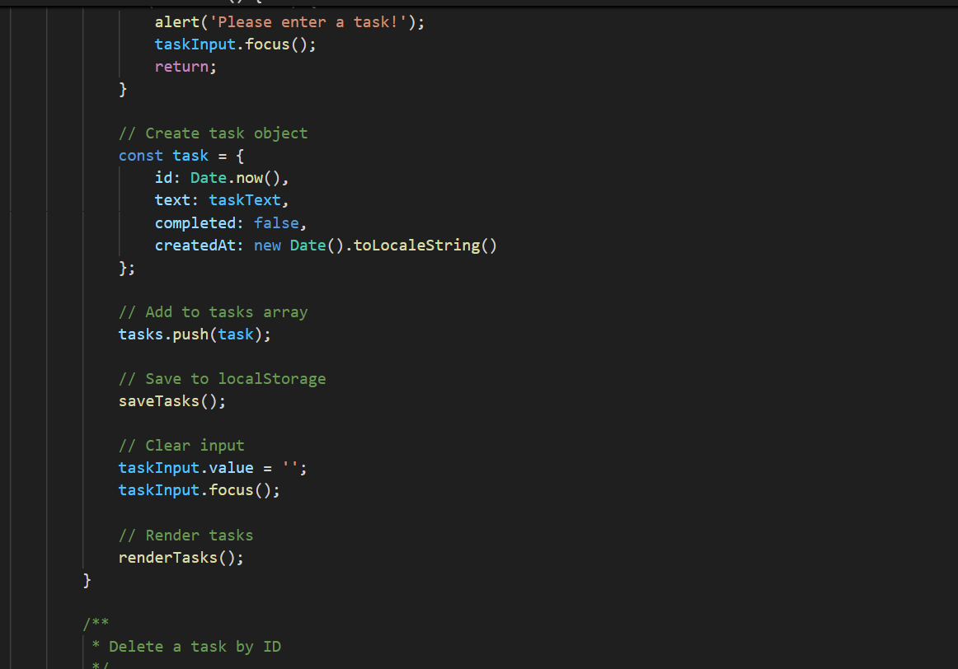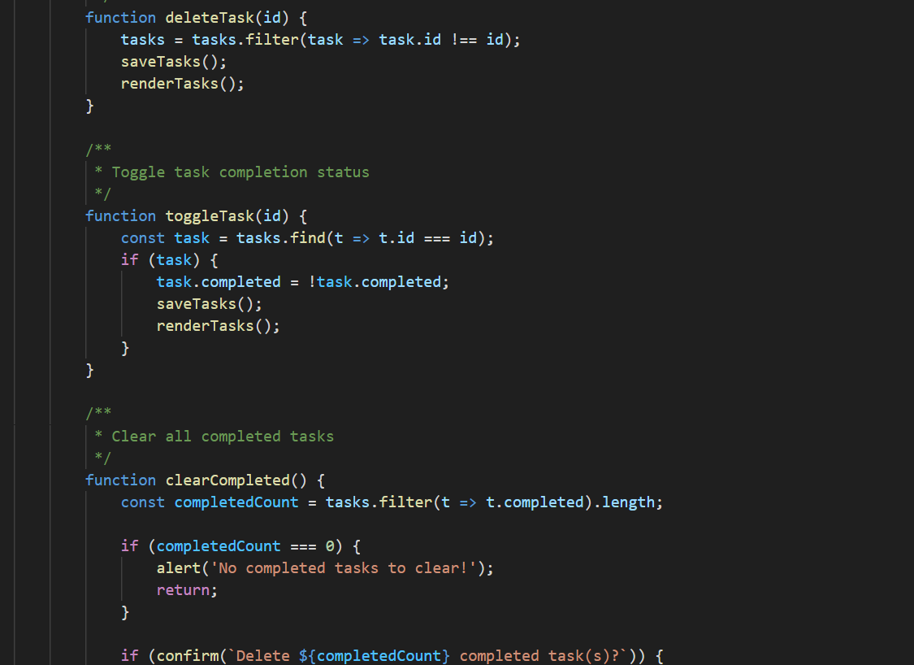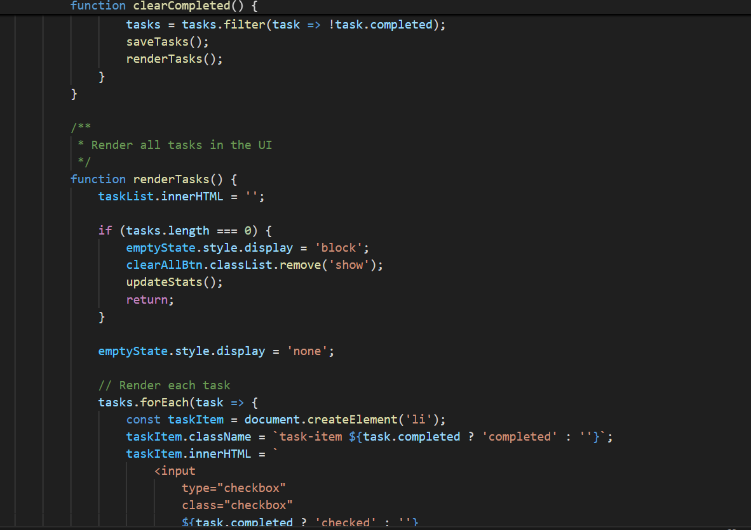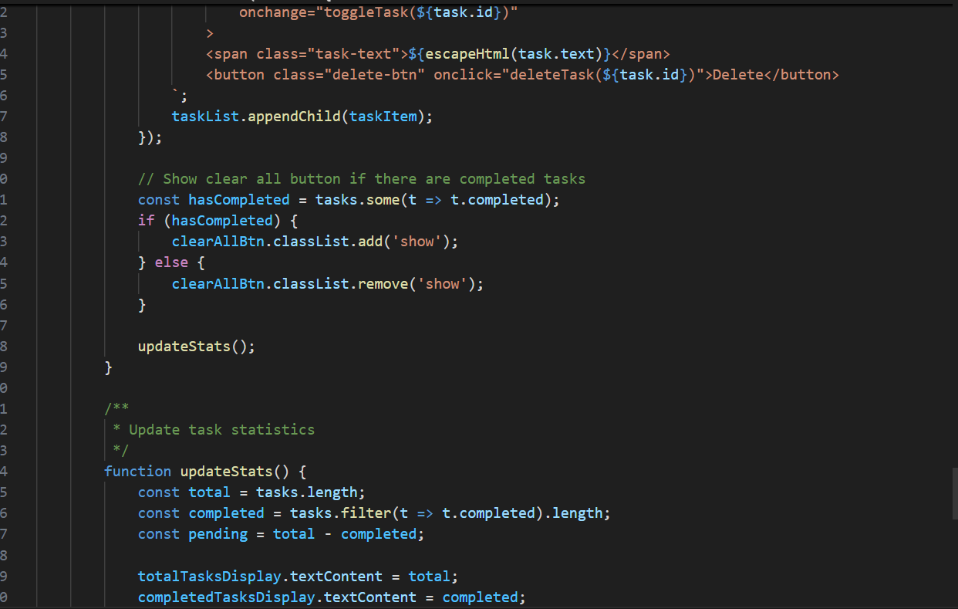
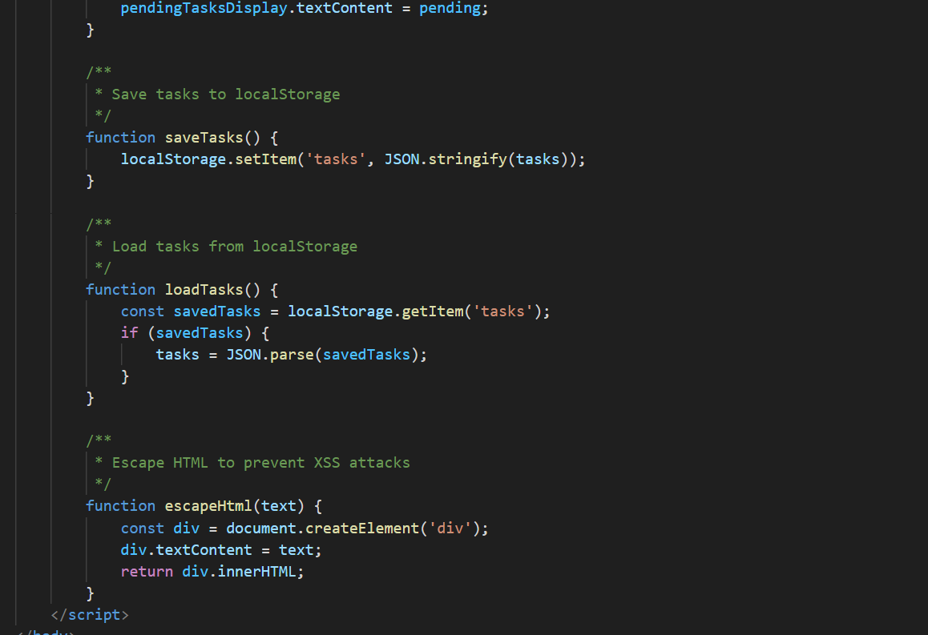
OUTPUT :
